Locator User Manual

Before using the locator, please read this User Manual carefully so as to install it correctly and use it quickly. The picture is for reference only and the actual product should prevail.

- Preparation before use

Check whether the device model is correct and whether the accessories are all in readiness.
Select the SIM card of the GSM network by referring to the advice of your distributor. (Turn off the cell phone first before installing the SIM card)
The GPRS function and the caller ID display function should be subscribed for the SIM card.
Install the APP client onto your cell phone. Please consult your distributor about the detailed information on the APP client.

- Product function

- Multiple Positioning Mode: GPS+ AGPS+LBS+WIFI
- Worldwide GSM+GPRS 4-frequency System: 850/900/1800/1900MHz
- Automatic Time Update: Precise GPS time service and no manual time adjustment is needed
- Track: The user's specific location can be inquired through the cell phone APP or the computer
- Fence: Designate an area on the map by setting the device as the center point and the alarm will be triggered off immediately once the user of the device goes into or out of this area
- PlayBack: Inquire the moving routes of the device in the past 3 months anytime and anywhere
- SOS: In case of emergency, press the SOS button and the device will send out the call and message for help to the guardian
- Walk: Counts the steps the user has walked
- Reward: The reward is sent out through the APP on the guardian's cell phone and the reward progress can be viewed
- Find Device: The lost device can be found through the APP on the cell phone
- Alarm: The alarm can set through the APP on the guardian's cell phone
- Anti-disturbance mode: Once the no-disturbance time range is set through the APP on the guardian's cell phone, the device will shield the voice messages and calls
- Voice: With the highly sensitive microphone, the sound around the device can be heard in real time in case the emergency happens to the user
- Remote Power-off: The device can be turned off through the APP on the guardian's cell phone
- Remote Restart: The device can be restarted through the APP on the guardian's cell phone
- Intelligent Power Saving: The device turns off/on the GPS and data upload in the time range specified through the APP on the guardian's cell phone

- Client operation instructions
3.1 Log in APP
a. Log in the APP by inputting the device IMEI number and password (default password: 123456) manually (please refer to the side of the device for the IMEI number).
b . Input the guardian's name, telephone number and the representative icon.
The guardian 's name/icon will be displayed in the Intercom. The telephone number is the one for remote listening.
The interface is as follows:
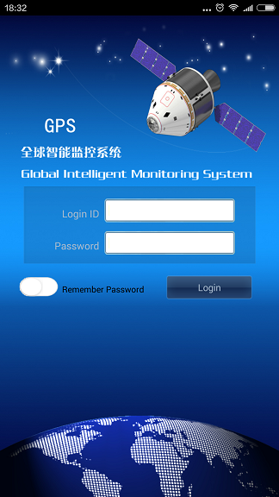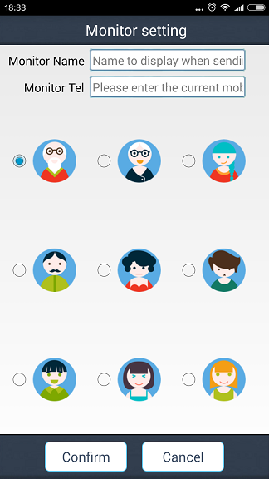

3.2 APP function menu
After the login is completed, you can proceed to the main interface of the functions.
The interface is as follows:
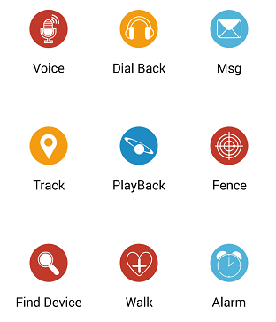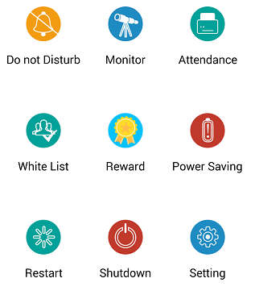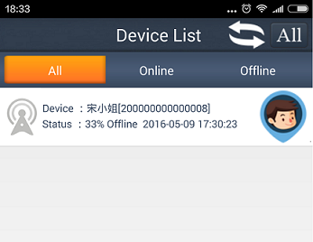
Press to select the device that needs to be supervised.
Press the name at the left side of to view and modify the specific information about the device.
Press "+" or "-" to add/delete the device.

Function explanation:
- . Voice: Set the supervising telephone number and after the confirmation, the device will call the already set telephone number automatically. The sound at the cell phone side cannot be heard at the device side, while the sound around the device can be heard at the cell phone side.
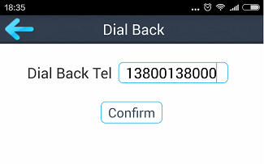

(2). Message:
After the device sets off various alarms, the client will receive the alarm message push and you can enter the information function to view the alarm content.
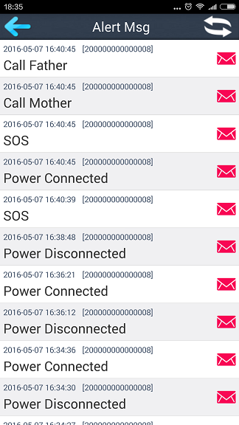
(3). Track: View the location of the device in real time.
The location of the device can be displayed at the map interface and the default upload interval of the location information is 10 minutes.
The icon represents the base station positioning, the icon indicates the GPS positioning and the icon means the WIFI positioning.
Press the icon to change the map mode.
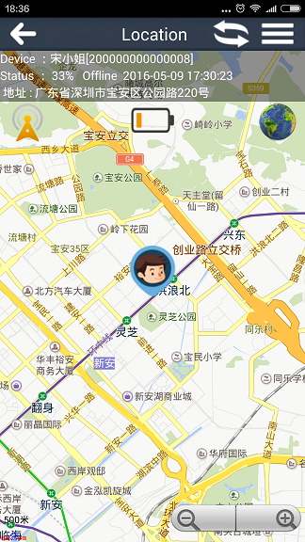
Press the icon to enter the function setting.
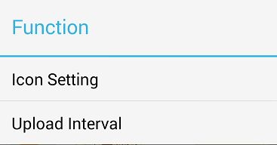

(4). PlayBack: The routes in the past 3 months can be viewed (the green water drop represents GPS, the blue water drop indicates LBS and the purple water drop means WIFI).
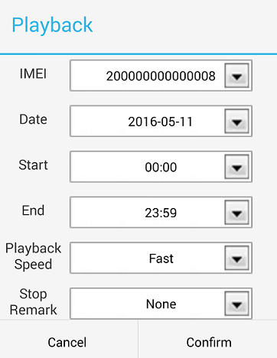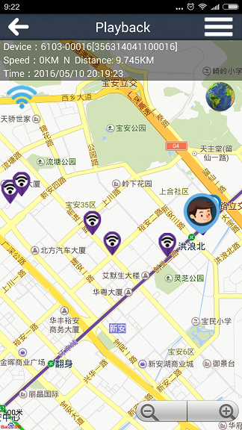

(5). Fence: 3 fences can be set and the minimum radius of the fenced area is 100 meters; when the user goes out of the fenced area (into the fenced area), the alarm information about the corresponding area will be generated.
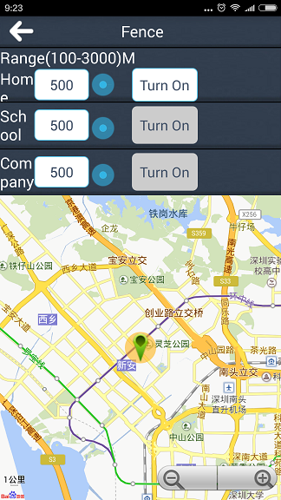

(6). Find Device: When the device is not by your side, you can send this command to ring the device so that you can find the device conveniently; press the Stop button the stop the ring.
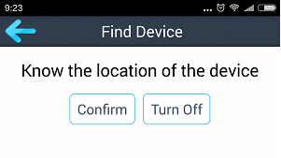
(7). Walk: Records the step count data in the past 7 days and drag the interface leftward or rightward to display the daily data.
Press button to turn on/off the step counting function and press button to refresh the step count data of the device.
Press the Mileage button to enter the interface to set the distance of each step and the weight, and to calculate the walking distance and the calorie.
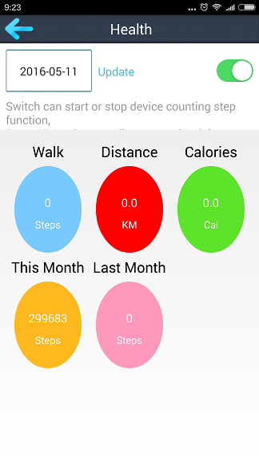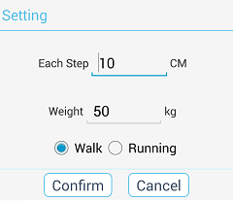

(8). Alarm: 3 alarms can be set and the alarm can be set according to your need.
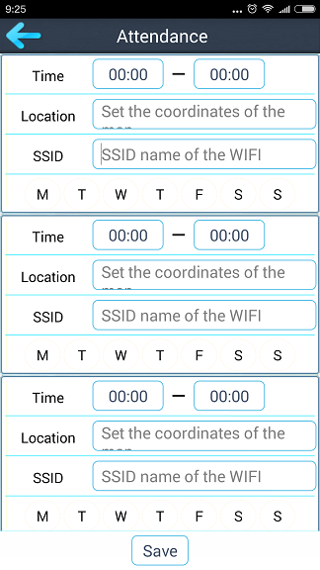
(9). No-disturbance Time Interval: All the calls and voices will be shielded during this time interval.
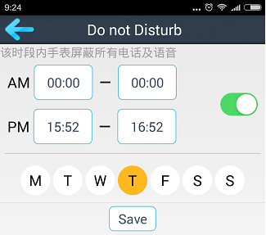

(10). Supervising telephone number: The device number, SOS number, father's and mother's cell phone numbers can be set.
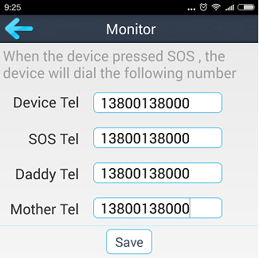

(11). Clocking-in: The alarm push prompt will be given off when the user enters or leaves the area specified on the map or the WIFI SSID in the set time interval.
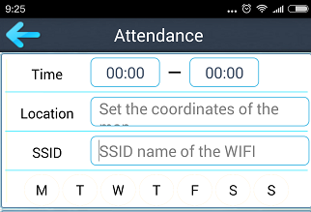
(12). White List: 47 telephone numbers through which the device can be called can be set.
Add: Press the Add New Contact button
Delete: Press and hold the contact to delete it
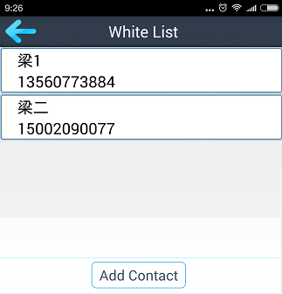
(13). Reward: Input the incentive targets and the number of times so as to award the praise when they are reached.
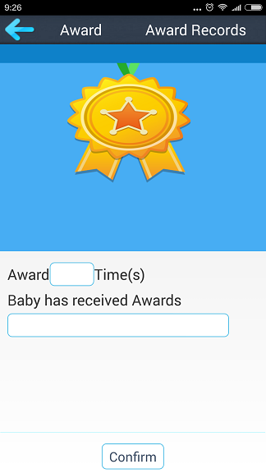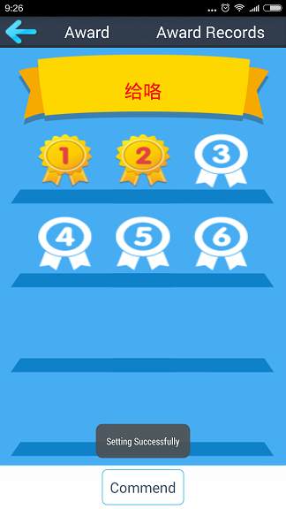

(14). Power Saving: You can choose to turn on/off the GPS positioning and turn off the data upload in the specified time.
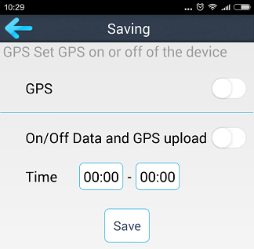
(15).Remote Restart: In case the abnormality of the device is found, you can restart the device.
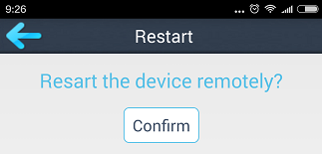

(16). Remote Power-off: It can turn off the equipment; after power-off, only the equipment has been turned on manually can the next operation be realized.
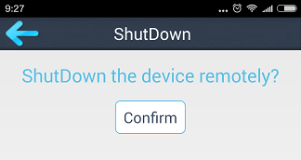

(17). Setting: Set the equipment.
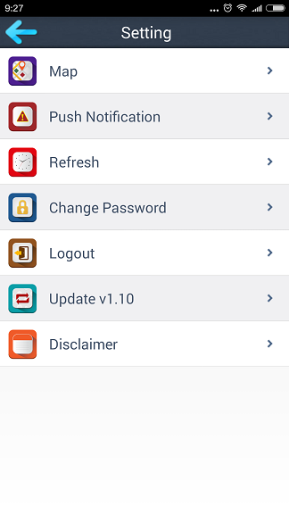

- Related operation instructions of the equipment

4.1 Button
a. Press and hold the button for 3 seconds to turn on the device; if there is no SIM card installed, press and hold the button for 3 seconds to turn off the device; after the SIM card is installed, press and hold the button for 9 seconds to turn off the device.
b. After the SIM card is installed and the device is under the standby status, press and hold the button for 3 seconds to allow the device to set off the SOS emergency alarm.
c. When the call from the related telephone number comes in, press the button briefly to answer the call and press it again briefly to hang up.
d. When the clock rings up, press the button briefly to stop the ring.

4.2 LED
Red LED: It keeps lighting up during the charging, flashes quickly during the lower battery, flashes slowly during normal electric quantity and goes out completely during the standby.
Yellow LED: It is for detecting the signal of the SIM card of the device; it flashes slowly under normal signal condition and flashes quickly when there is no signal.
Blue LED: It means the device can receive the GPS signal; it flashes slowly under normal signal condition and flashes quickly when there is no signal.

4.3 SOS emergency alarm of the device
After the SIM card is installed and the device is under the standby status, press the SOS button for 3 seconds and the device will dial 3 supervising telephone numbers in turn for one time each. During which, if the call is answered, the dialing will not be continued; if not, it will be continued till one round of dialing is finished. Meanwhile, the alarm notice will be sent to the APP.

4.4 Default password
Text the message "pwrst" to the device number to restore the password to the default one. And the device will reply: "The password has been cleared successfully".

4.5 Restore to the factory settings
Text the message "1122" to the device number and the device will restart automatically and reply: "The factory settings have been restored to successfully".

4.6 Modify the time interval of the positioning upload
Text the message "time#+number" (time#1 can be set to 1-60 minutes) to the device number and the device will reply with the message "time#+number".

5. Troubleshooting
When the device is turned on for the first time, it cannot be connected to the server and the APP sends the command that shows the device is not connected to the network yet. Please check:
5.1 Whether the SIM card has been inserted into the device correctly.
5.2 Whether the SIM card inside the device supports the GSM network; for example, it does not support the China Telecom network.
5.3 Whether the data traffic service of the SIM card inside the device has been subscribed; it must support the data traffic of the 2G network and the device can use only the data traffic of the 2G network currently.
5.4 Whether the IMEI is correct; it must ensure that the IMEI bar code adhered to the device is consistent with the IMEI that is written into the device before it leaves the factory.

6. QR code scanning access
The client for the Android and iOS phones can be downloaded after the QR code has been scanned.

Android application iOS application
Service platform:www.365gps.net
Android application 365gps
iOS application: 365gps
7. Remote management
The user can use the PC or cell phone platform to directly manage and view the functions such as Find Device, PlayBack, Fence etc.
7.1 Web
Please visit www.365gps.net and use the user name or IMEI number to log in the platform; the default password is 123456
7.2 Android cell phone
Please visit www.365gps.net/app/365gps.apk
7.3 iPhone
Please visit https://itunes.apple.com/cn/app/365gps/id1068418498?mt=8 in AppStore to download the APP.

