**SDI to ALL Scaler Converter**

**Operation Manual**

1. **Introduction**

The SDI to ALL Scaler Converter allows SD, HD and 3G-SDI signals to be shown on HDMI/DVI/VGA/Composite port display. This means that it is now easier for professionals to distribute and extend their SDI signal while giving the ability to display work on these display. Furthermore, thanks to L/R audio outputs users can output analog audio formats while the loop-through 3G-SDI design benefits users by letting them simultaneous show content on both SDI and HDMI/DVI/VGA/Composite port displays.

1. **Features**

* Supports SD-SDI, HD-SDI and 3G-SDI input signals with auto-detection;
* Supports HDMI/DVI/VGA/Composite and SDI (bypass) output simultaneously;
* SDI interface operates at bitrates of 2.970 Gbit/s, 2.970/1.001 Gbit/s,  
  1.485 Gbit/s, 1.485/1.001 Gbit/s and 270 Mb/s;
* Supports SDI input/output distance up to 100 meters (3G-SDI), 200  
  meters (HD-SDI), or 300 meters (SD-SDI);
* Scale any SDI signal to HDMI/DVI/VGA/Composite:  
  1. HDMI/DVI/VGA timings: 1280x720,1920x1080,1024x768,1920x1200;  
  2. Composite format: PAL,NTSC;
* Supports SDI input modes:  
  1. SD-SDI (SMPTE 259M-C, at bitrates of 270 Mbit/s)  
  2. HD-SDI (SMPTE 292M, at bitrates of 1.485 Gbit/s and 1.485/1.001 Gbit/s)  
  3. 3G-SDI (SMPTE 424M/425M-AB, at bitrates of 2.970 Gbit/s and  
  2.970/1.001 Gbit/s)
* Supports Black screen signal output;
* Equalized and re-clocked loop output;
* Alternative audio output to analog 2CH;

1. **Package Contents**
   * SDI to ALL Scaler Converter 1pcs
   * 12V/2.5A DC power adaptor 1pcs
   * Operation Manual 1pcs
2. **Specification**

**SMPTE Standard** 425M Level A & B, 424M, 292M, 259M-C  
**SDI Transmission Rates** 2.970Gbps, 2.970/1.001Gbps,1.485Gbps,  
 1.485/1.001Gbps, and 270Mbps  
**Input Port** 1×BNC (SD/HD/3G-SDI)  
**Output Port** 1×BNC (SD/HD/3G-SDI bypass),

1×HDMI (Type A connector),

1×DVI with Audio

1x VGA with Audio  
 1×Composite with R/L  
**ESD Protection** Human-body Model:  
 ±8kV (air-gap discharge)  
 ±4kV (contact discharge)  
**SDI Cable Distance** 3G up to 100m (BELDEN 1694A Cable)  
 HD up to 200m (BELDEN 1694A Cable)  
 SD up to 300m (BELDEN 1694A Cable)  
**Dimensions** 110mm (W)×288mm (D)×32mm (H)  
**Weight** 750g  
**Chassis Material** metal  
**Operating Temperature** 0 ˚C~40 ˚C/32 ˚F~104 ˚F  
**Storage Temperature** −20 ˚C~60 ˚C/−4 ˚F~140 ˚F  
**Relative Humidity** 20~90% RH (Non-condensing)  
**Power Consumption** 5W

1. **Operation and Fuctions**

**5.1 Front panel**

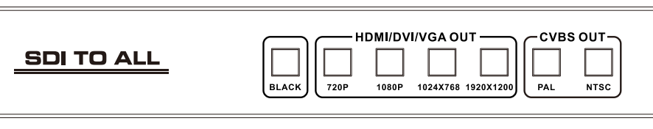

1. **BLACK Button:** Press this button will output Black screen signal to HDMI/DVI/VGA/Composite port display.
2. **HDMI/DVI/VGA OUT button:** Press these buttons to select the HDMI/DVI/VGA port resolution.
3. **CVBS OUT button:** Press these buttons to select the composite output port format.

**5.2 Rear panel**

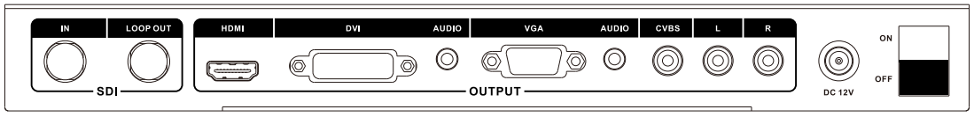

1. **SDI IN:**Connect to the SDI output of the SDI source device.Accepts SD,HD or 3G SDI signals.
2. **SDI LOOP OUT:** Provides a 'loop-through' SDI signal output for connection to a SDI display.
3. **OUTPUT:** These slot is where you connect the HDMI/DVI/VGA/Composite port display with cable for input source display.
4. **DC 12V:** Plug the 12V DC power supply into the unit and connect the adaptor to AC wall outlet.
5. **ON/OFF:** Power ON/OFF.

**6. Connection Diagram**

