HDMI 1.4 Matrix 6×2

User manual
V2.2

Thank you for purchasing this product. For optimum performance and safety, please read these instructions carefully before connecting, operating or adjusting this product. Please keep this manual for future reference.

- Introduction
The HDMI matrix 6*2 with 4kx2k supported which allows HDMI signal from any of its six sources to be routed to and displayed on any of its two connected HDMI displays simultaneously. It supports 3D, 3Gbps bandwidth, 12-bit Deep Color, Hi-Def lossless audio and other features defined by HDMI specifications. The management of source/ sink scenarios can be operated easily through on-panel buttons, IR remote control.

- Features
- Compliant with HDMI 2.0; HDCP2.2
- Support video format up to 4k2k@30Hz with 24bit RGB/YcbCR 4:4:4/YCBCR 4:2:2, and up to 4k2k@60Hz with 12bit YCBCR 4:2:0, 3D frame sequential video format up to 1080p@60
- Support MHL input, Share your smart phone photos, music and movies on the TV.
- Support PIP display function and ARC function.
- Audio support: HDMI 1.4 compatible audio interface Dolby TrueHD DTS-HD Master Audio 7.1CH

- Package
- HDMI 1.4 Matrix 6*2---------------------------------------------------1PC
- 5V/2A DC Power Supply Adapter-----------------------------------1PC
- Remote control----------------------------------------------------------1PC
- Operation Manual ------------------------------------------------------1PC
- Mounting ears-----------------------------------------------------------2PCS
- Specifications
Frequency Bandwidth 2.97Gbps
Input Ports 6 x HDMI Female.
Output ports 2 x HDMI Female; 1x Toslink; 1x Earphone
HDMI Audio Output PCM2, 5.1, 7.1CH, Dolby 5.1, DTS5.1, D-TrueHD, DTS-HD
Power Supply 5V/2A DC (US/EU standards, CE/FCC/UL certified)
ESD Protection Human Body Model: ± 8kV (air-gap discharge)
± 4kV (contact discharge)
Dimensions (mm) 250(D) x110 (W) x 26(H)
Weight (g) 720
Power Consumption(max) 10W
Operating Temperature 0˚C ~ 40˚C / 32˚F ~ 104˚F
Storage Temperature -20˚C ~ 60˚C / -4˚F ~ 140˚F
- Operation controls and Functions
Front Panel
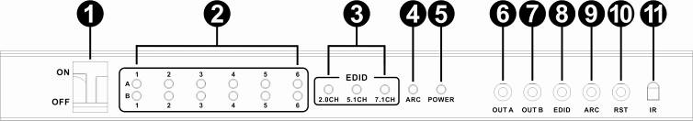
- ON/OFF: Power on/off switch.
- Input LED: These green LED illuminate when the output select to the corresponding input.
- EDID LED: These green LED illuminate when the audio EDID select to corresponding audio.
- ARC LED: This green LED illuminate when the ARC function open.
- POWER LED: This green LED illuminate when the device is connected with power supply.
- OUTA KEY: Press this button to select the input source to HDMI OUT A.
- OUTB KEY: Press this button to select the input source to HDMI OUT B.
- EDID KEY: Press this button to select the 2.0CH, 5.1CH, 7.1CH audio output mode.
- ARC KEY：Press this button to open or close the ARC function.
- RST KEY: Press this button the matrix will reset to factory state(INPUT1, 2.0CH AUDIO MODE,ARC function closed)
- IR: Remote control signal receive.

Rear Panel
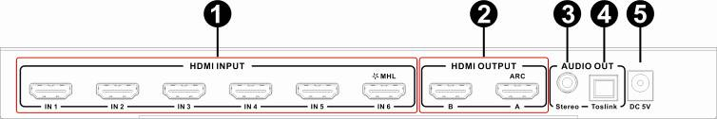
- Input Source: These slots are where you connect the HDMI source output from DVD, PS3.
- HDMI OUT: This slot is where you connect the HDTV or monitor with HDMI cable.
- Stereo OUT: This slot is where you connect to the speaker with 3.5mm earphone cable.
- Toslink OUT: This slot is where you connect to the amplifier with optical fiber cable.
- DC IN: Plug the 5V DC power supply into the unit and connect the adapter to AC wall outlet.
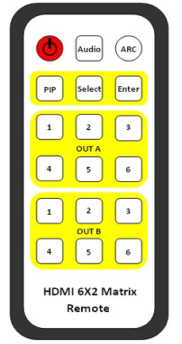
Attention:
- The Toslink and Stereo audio follow the OUT A HDMI audio.
- The In1 (The first input port) support HDCP2.2 input only.
- The In6 (The sixth input port) support MHL input only, use MHL to HDMI Cable to connect smart phone and matrix.
- The output A support ARC function only.
- Remote control
STANDBY: Press this button will standby or power on the matrix.
Audio EDID: Press this button will Select the audio output mode (2.0CH,5.1CH,7.1CH), and the LED will indicate the corresponding state .
ARC: Press this button will Open or close the ARC function, and the LED will indicate the corresponding state.
PIP: Press this button will Open or close the PIP function. When open PIP function, the OUTA and OUTB will switch to the same input source.
Select: Press this button will select the PIP source.
Enter: Press this button will confirm the select PIP source.
OUTA: Press these buttons will fast switch to select input source to HDMI OUTA. And the LED will indicate the corresponding input source.
OUTB: Press these buttons will fast switch to select input source to HDMI OUTB. and the LED will indicate the corresponding input source.
※ARC function: If you need to use ARC, your HDTV must support this function, when you open the ARC function, the Toslink of the Matrix will output the HDTV current display content audio. Otherwise it will output the Matrix input source audio.
- Application Example
