CNC Control Board Manual
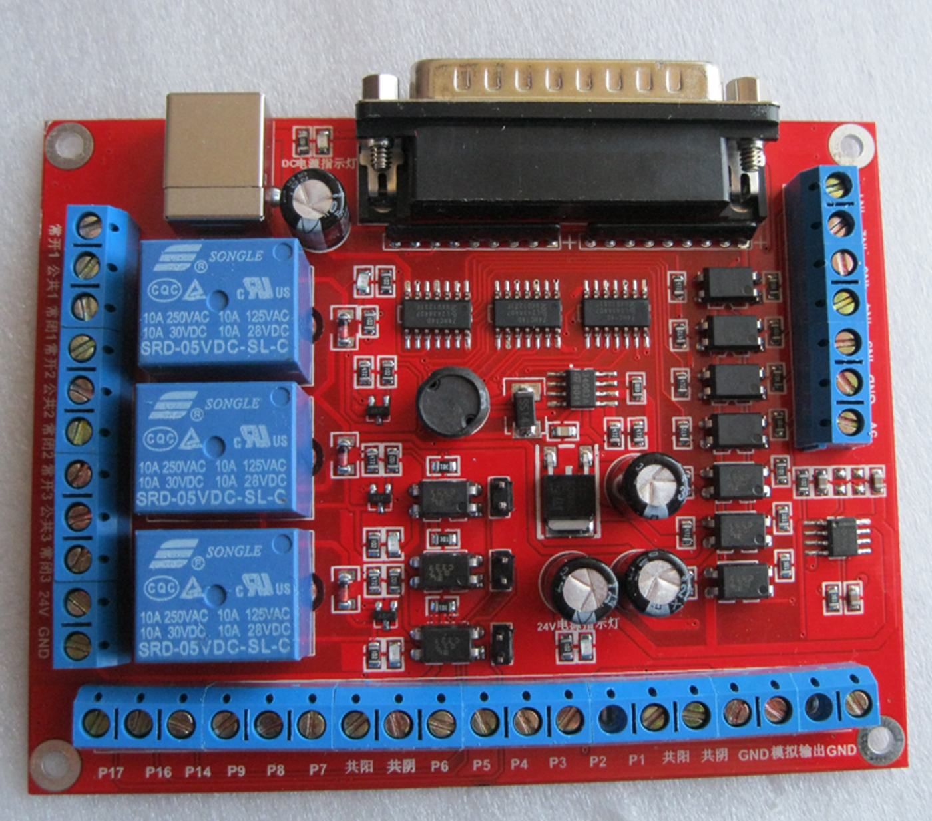

Pls read this manual carefully for reference before using the board.
Pls put this manual away for further reference.
Pictures are just for references pls make the object as the standard.

Safety Notes:
The control board is applied with DC power, pls assure that the positive and negative charges are right connected before the power on.

The control board is not strictly sealed,pls do not let conductive objects like small screws or scrap metal go inside. Neither do combustibleobjects.

Keep the board from damp environment.
Keep the board in adequate ventilation.

Usage:
The CNC control board is designed for MACH3 software used in computer with line print terminal.The CNC control board is extensively used in the CNC machining,such as: CNC engraving machine,CNC lathes,CNC Plasma cutting machine,CNC laser engraving machine,CNC milling machine,CNC Machining center and so on.It can be the most cost-effective method using the CNC control board with mach3 software in the computer.

Features:
1. High integration；high reliability

2.Absolute voltage isolation. The CNC control board is powered by computer USB port used as digital power that disgned as common cathode and common ancode which is connecticed to motor dirver’s common port,and another power is DC 12V to DC 24V which is used as analog power.It’s much more safe and stable by isolating the digital power from analog power.

3.Five signal ports are isolated by optocouplers which can be used as limitting position，finding origin points,starting and Estopping. There is no interruption with isolation of optocouplers.

4.Twelve output ports can control six motors simultaneously,and they are also can be used for some ports as you like.Some ports are communally designed for two functions,choice should be made if you want to use them.

5.Three relays are put on the board that can be programmed in the mach3 software,and there are three leds used for pilot lamp.The relays can be used to control external equipments such as solenoid valve, cooling pump and so on.

6.Programmed analog voltage from zero to ten volt can be set.The analog voltage can control the speed of spindle motor.

7. The CNC control board can control step motor diver with common cathode or common anode.It also can control servo motor with digital signal.

8.The analog power can be from nine volt to thrity volt.

